Tuesdays & Thursdays
1:30pm-2:00pm
ROOM 818

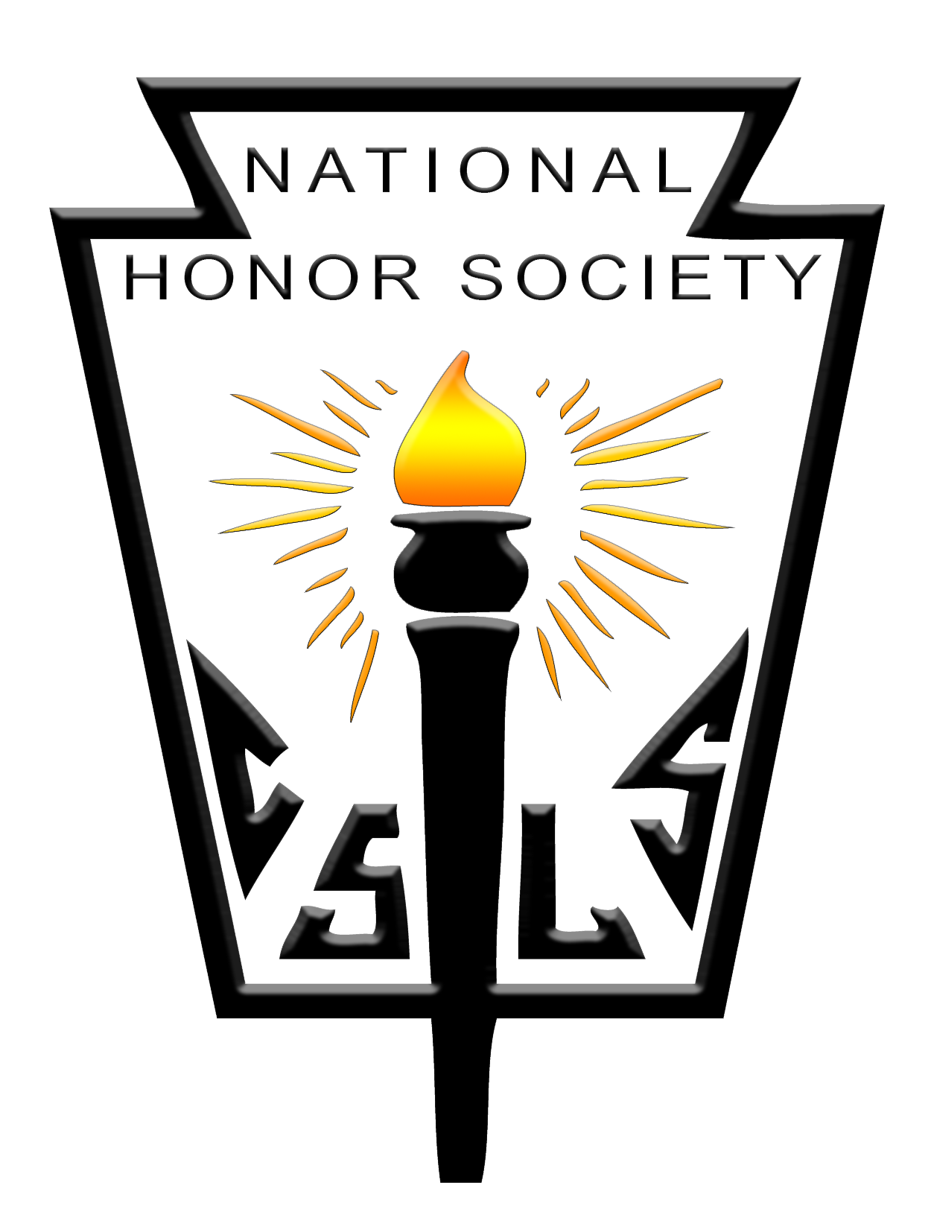
See your counselor if you have questions!
Sponsored by the students of the
SRHS National Honor Society

